User Guide
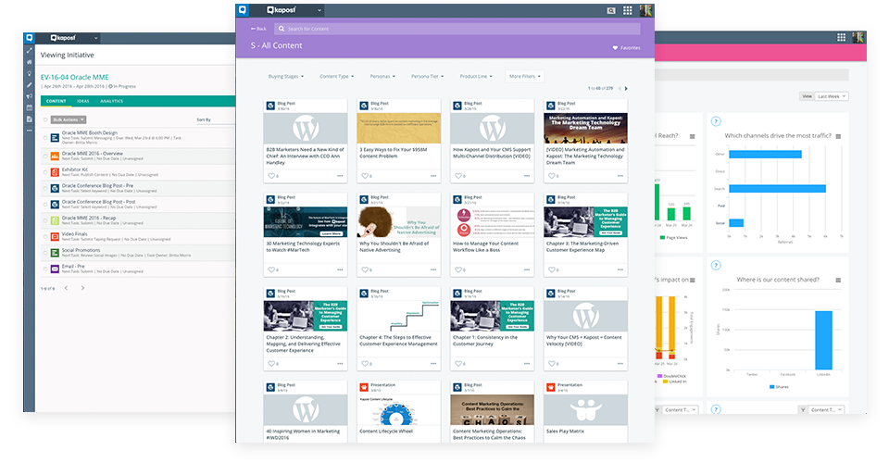

[Company Name/Date/Logo]

Welcome to Kapost! 3
[Company Name]’s Content Operations Vision Statement 3
Getting Started 4
Accept Kapost’s Invite 4
Check Your Browser 4
Set up Your Profile 4
Using Kapost Studio 6
Navigating Studio 6
Catalogs 7
Saved Views 8
[Company Name]’s Saved Views 8
Creating Ideas 9
External Idea Submission 10
[Company Name]’s Crowdsource Forms 10
Creating Content 10
[Company Name]’s Content Types 12
Uploading Content 12
Document Annotations 13
Using Workflows 15
Editing Tasks 15
Checking Off Completed Tasks 16
[Company Name]’s Custom Workflows 17
Tagging Content 17
[Company Name]’s Custom Fields 18
Activity Feeds 19
Creating Initiatives 20
[Company Name]’s Initiative Types 23
[Company Name]’s Initiative Templates 23
The Calendar 24
[Company Name]’s Calendar Saved Views 25
Bulk Actions 25
Publishing Content 26
[Company Name]’s Kapost Integrations 26
Additional Information 26
The Kapost Gallery [Delete if not needed] 26
Why We Use Gallery 26
Who Accesses Our Galleries 26
How to Organize Content for the Gallery 27
Who on Our Team Manages the Gallery 27
Kapost Glossary 28

Welcome to Kapost!

[Company Name]’s Content Operations Vision Statement
[INSERT CUSTOMER CONTENT OPERATIONS VISION STATEMENT AND BUSINESS OBJECTIVES]

EXAMPLE
Our vision for content operations at [Company Name]:

Content operations at [Company Name] is a thoughtful yet agile machine that plans and supports content creation and distribution to strategically connect with customers, partners, and employees through impactful brand stories and experiences.

Content operations vision success criteria:
- Decrease percent unplanned, non-strategic content
- Increase frequency of cross-team alignment meetings
- Plan and maintain regular content calendars
- Increased brand visibility and satisfaction
- Increase digital content (5 priority channels) outputs
- Increase content reuse
- Increase amount of content aligned to strategic fields (buyer, etc.)
- Increase employee satisfaction
- Increase number of qualified interest

We are partnering with Kapost to:

- Build a Content Operation: Align teams, tools, and processes to support business objectives
- Synchronize activities and messaging: Develop a centralized editorial calendar
- Optimize planning and production: Mapping content to personas, buying stages, product lines, etc.
- Create visibility across teams
- Centralize efforts in one tool and reduce duplicated and wasted resources
- Promote accountability and visibility of production cycle
- Enable more efficient content distribution and consumption (e.g., internal teams like marketing and sales)
- Enable governance of content: approvals, workflows, tasks, etc.

Getting Started

Accept Kapost’s Invite
Your organization has its own custom URL. You should have received an email invitation from your organization with information about setting up your account. Click the Join Now link in the email to create a unique password and login.

Check Your Browser
Kapost supports the same browsers that Google supports, which are the current version of Microsoft Edge and the current version and one previous version of Chrome, Firefox, Safari, and Internet Explorer. For browsers other than Chrome, you’ll want to have an updated version of Flash installed.

Set Up Your Profile
- Click your name in the top right corner of the top navigation bar in Kapost. Click View Profile.
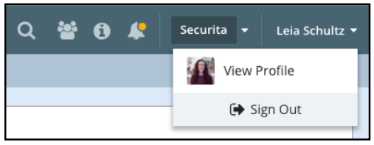
- Click the Edit Profile button to update your profile and notification preferences.
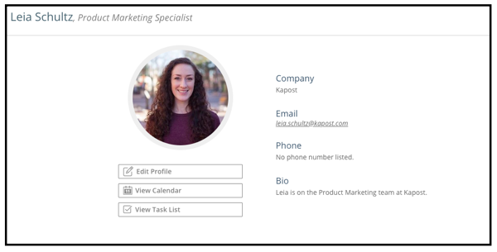
- In the Personal Information tab, add your name, your company name, your job title, a photo, and any other details like a short bio that would be helpful to the teams you’ll work with in Kapost.
- The Email Notification Settings tab is where you can adjust your notification settings. Over time you’ll figure out what works best for you, but to get started, we recommend choosing to receive emails when your task is up next on content. You can always come back and adjust these settings as needed.
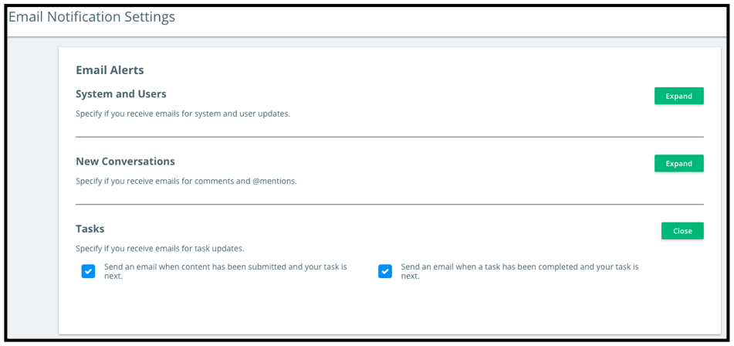
- When you’re done, click Save Changes.

Click here to watch a short video tutorial on making the perfect profile.

Using Kapost Studio

Navigating Studio
The Kapost platform is composed of four applications: Canvas, Studio, Gallery, and Insights. This guide covers Studio, which is where you’ll be creating and collaborating on content and campaigns.

Once you login, you’ll arrive on the Studio homepage. This homepage shows you information about and links to the content, campaigns, tasks, and activities in your content operation.

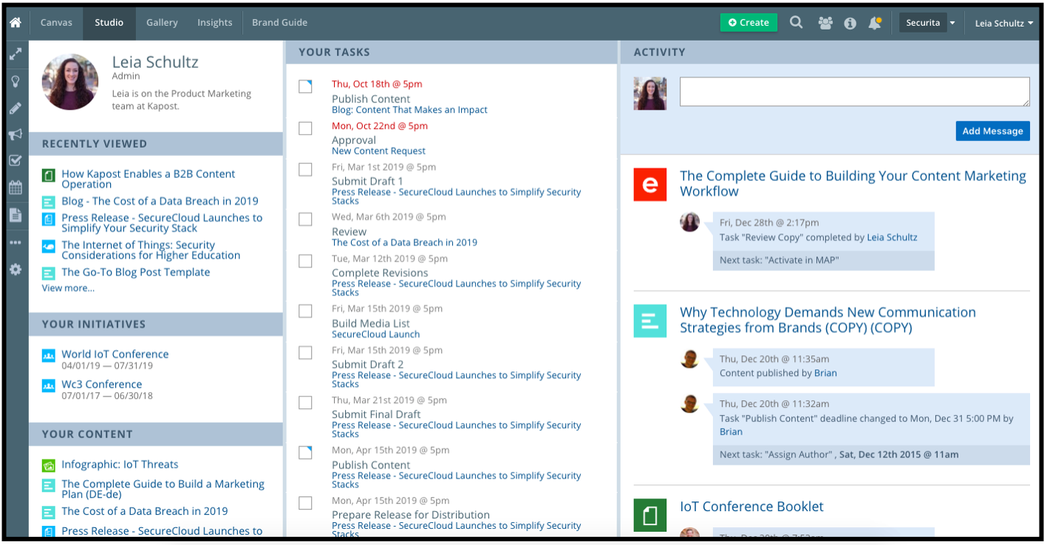
Key areas on this page are:
- Top Navigation Bar, where you can do things like select a Kapost application to navigate to, create content assets, search content, view notifications, and update your profile
- Your Name and Role, which shows your profile picture, role, and a short bio if you choose to add it
- Recently Viewed Content, which shows the content you recently viewed in Kapost and links to navigate back to the them
- Your Initiatives, where you can see the campaigns you own in Kapost
- Your Content, which shows a list of the content you’re assigned to or have a task on
- Your Tasks, ordered by their due date, where you can see a to-do list of what you need to complete for the content and initiatives you’re collaborating on
- Activity Feed, where a feed of updates and comments on content are visible and a place where you can post a general comment to everyone in Kapost
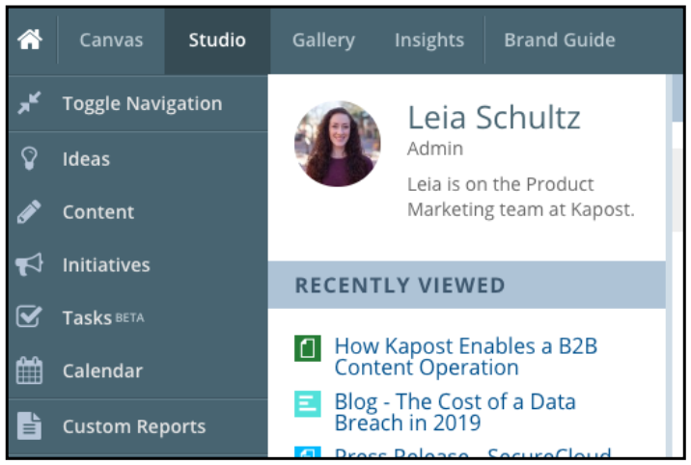
You’ll also see a sidebar navigation on the left side of your homepage in Studio. Use it to navigate to your catalogs for ideas, content, initiatives, and tasks, along with the calendar.

Only certain Kapost user roles will see the option for Custom Reports. Admins will see additional settings options here.

Pro Tip: Once you’ve been in Kapost for a bit and know your way around, bookmark the page in Kapost you visit the most to access it quickly when you need to work in the platform. Popular pages to bookmark include Task Catalog and the calendar.

Catalogs
Use your sidebar navigation in Studio to go to your catalogs for Ideas, Content, Initiatives, and, if it’s part of your Kapost platform, Task Catalog (beta). These catalogs are your organization’s inventory of the content and campaigns, and the ideas that help inspire them. You’ll see that your Ideas, Content, and Initiatives Catalogs look similar:
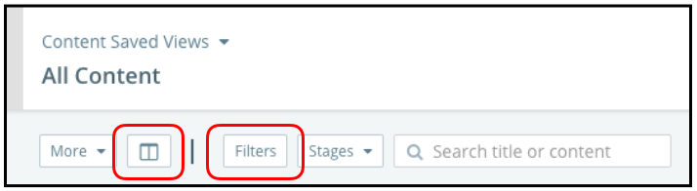
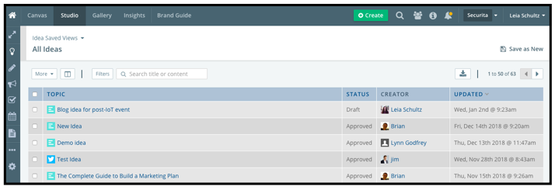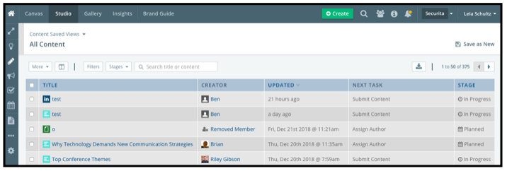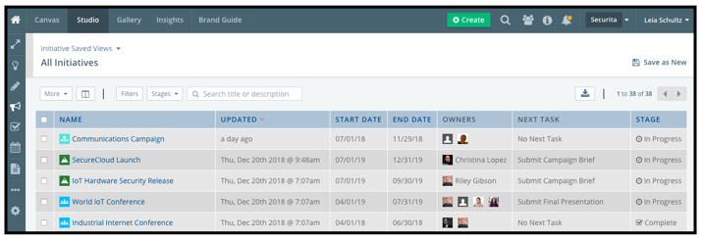
When you go to a catalog, your view will be made up of certain columns and filters. Using the buttons for columns and filters, you can choose which columns and filters you want to apply to a view,customizing the information displayed.

Customizing your catalog views is an important functionality to master: This enables you to create your saved views (discussed in the next section) or the views you’ll come back to most often to see just the information that’s most relevant to you.

You’ll see a number of options for the columns and filters you can apply in your catalogs. Keep in mind that your custom fields are options to apply to your views (for example, you might have a custom field for language if you want to sort your catalogs to show just content in French).

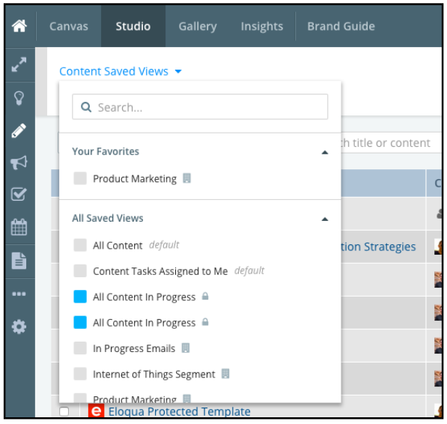
Saved Views

Saved views are your personalized views for content, initiatives, tasks, and the calendar that allow you to quickly and easily navigate to the most relevant, helpful information about your to-do list.

Set up saved views in your catalogs and skip having to search for or apply filters and columns each time you visit a catalog.

Share your views with team members and managers using Manage Access functionality so that these key stakeholders can see what you do.

For more information on setting up your Saved Views, watch this short video tutorial.

[Company Name]’s Saved Views

Creating Ideas
Ideas in Kapost allow you to request needed content or record an idea for content that you’d like to plan to create.

To create an idea, select the green Create button in the top navigation bar. In the pop-up modal, click on the tile for Idea. Fill in the idea’s details: its topic, the type of content, and specifics on your idea for the content.

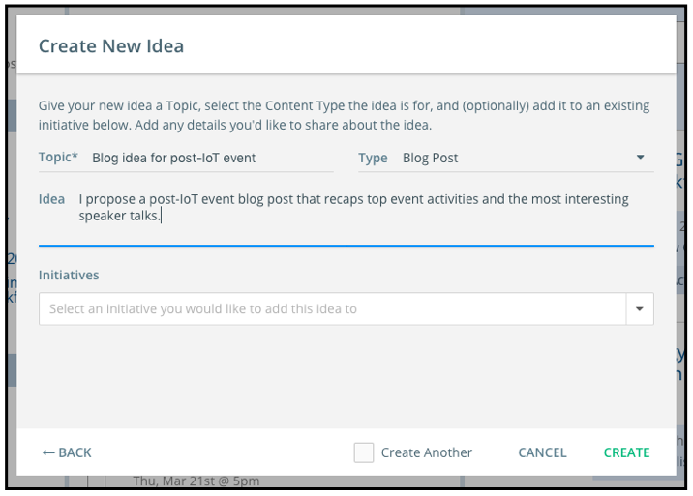
Click the green Create button and you’ll be taken to a details page where you can fill in additional information, add supporting attachments, and alert team members to your idea by @-mentioning them in the idea’s activity feed.
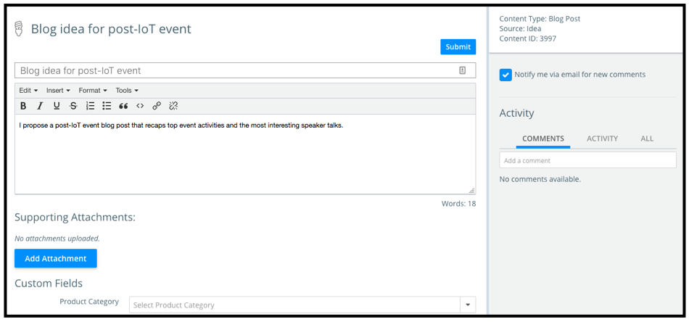
The idea will be added to the Ideas Catalog when you click the blue Submit button from the details page. You can always save a draft idea to come back to later before you submit it.

External Idea Submission
The crowdsource form allows you to source ideas from people without Kapost licenses, so that external people can submit an idea for content into your Kapost platform. When a crowdsource form is used, once submitted, that idea will display in your Ideas Catalog.

[Company Name]’s Crowdsource Forms
[INSERT ANY IDEA SUBMISSION FORMS, RULES OR REQUEST PROCESSES THAT HAVE BEEN SET FOR YOUR KAPOST USERS]

Creating Content
You’ll create content in the Studio app, from blog posts and case studies to emails and beyond.
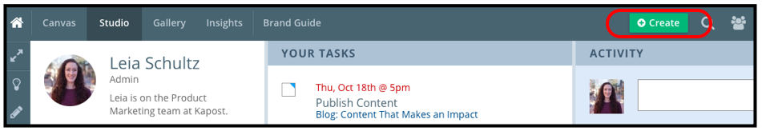
To create a new piece of content, click on the green Create button in the top navigation bar.

A pop-up modal will appear where you’ll choose what you’re creating: an initiative, content, or an idea.
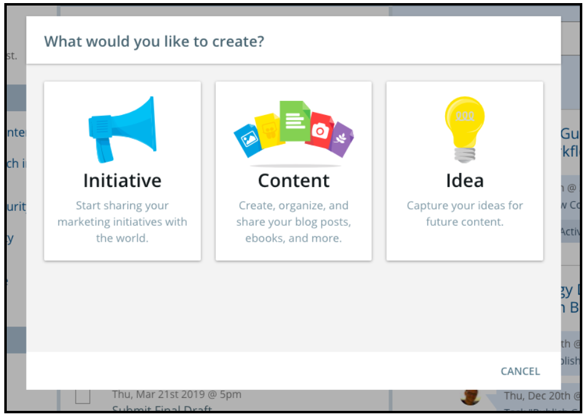
Click on the Content tile to continue to enter in details for what you’re creating. In the pop-up modal, you’ll be prompted to give it a title, select what type of content it is, and add it to an initiative or campaign. This information can be updated later as needed.

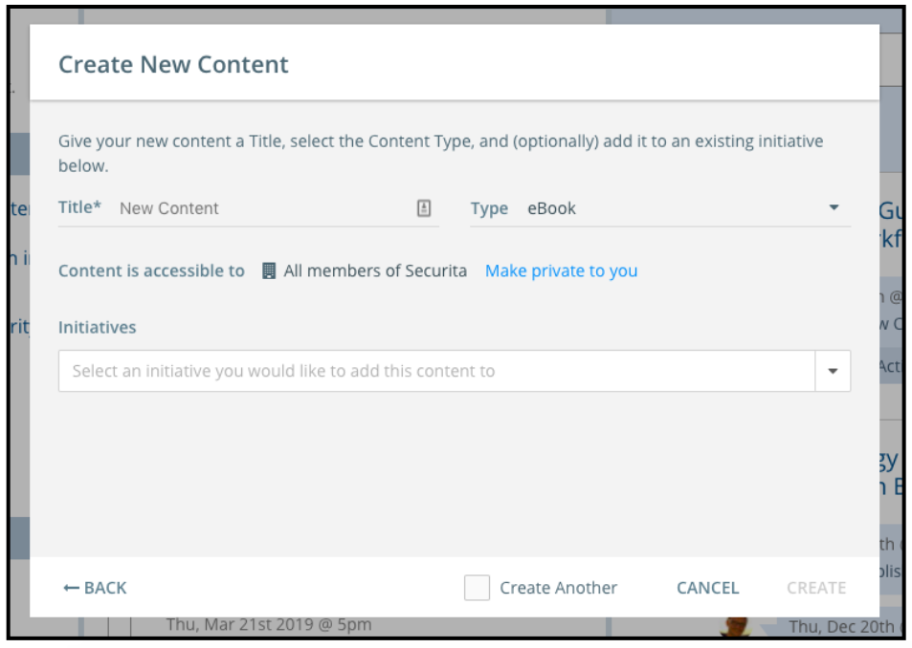

[Company Name]’s Content Types
[INSERT EACH CONTENT TYPE USED IN YOUR KAPOST INSTANCE AND ITS DEFINITION]
When viewing any piece of content in Kapost, you’ll see five standard components on the content details page:
- A box in the top right of the page that shows the content type and its stage (planned, in progress, or complete)
- An area to create and/or upload content, called the body of content
- A section below the body of content add custom fields to the content, which categorize it and define its purpose
- A workflow of the tasks needed to execute the content
- An activity feed where you can @-mention team members and see updates on the content’s progress

These components will be discussed in detail in this guide.

Uploading Content
Some content types are configured to allow you to upload a file or an image to the body of content. When prompted, you can upload content into Kapost via drag-and-drop, browse your files, import from Dropbox or Box, or via the file’s URL.
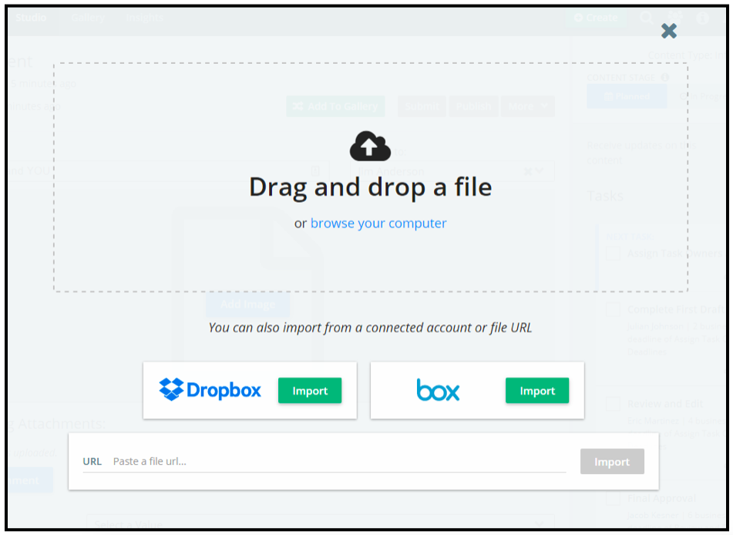

Exceptions:
- HTML content, which is edited in the open text field body of content
- Emails, which can be pulled in from your marketing automation platform
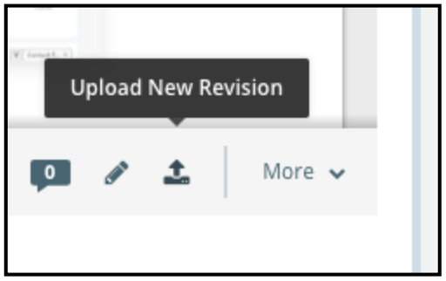

As the content progresses, upload the latest revision into Kapost. To upload a new version, click the upload icon below the body of content to browse for the file to add.

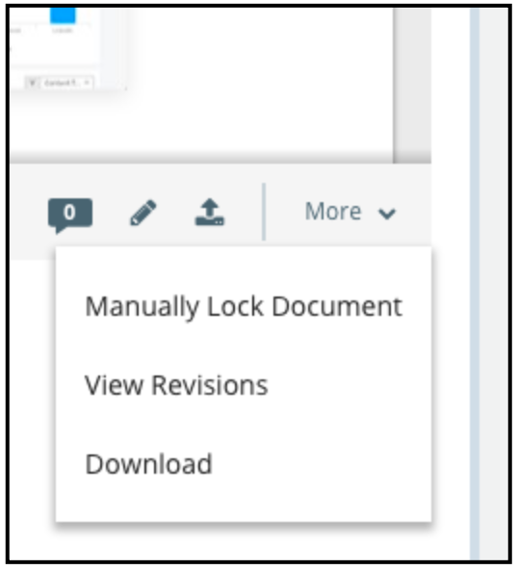

Kapost will keep all previous versions, so historical changes to content can be tracked. To see previous versions of content, go to the More drop-down menu below the body of content and select View Revisions.

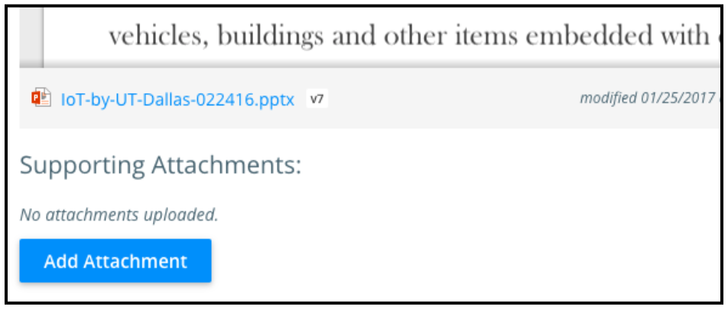
You can also add supporting attachments to content assets in Kapost. Find the Add Attachment button below the body of content.

Document Annotations
Kapost’s Document Annotations feature helps team members collaborate on certain content types in Kapost, like PDFs or flyers. Document Annotations enable you to clearly see comments and edits on content, including viewing previous versions and resolved comments.
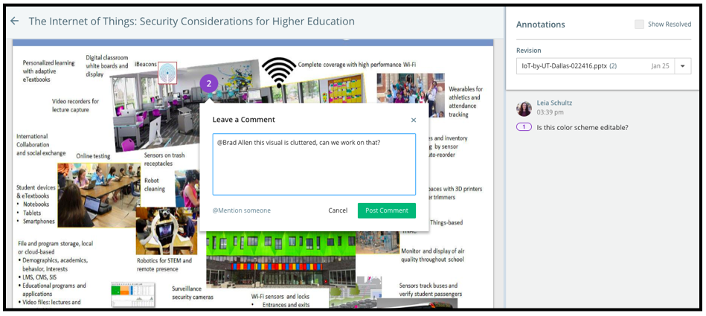

Use Document Annotations to:
- Add and view annotations on content
- Make, edit, and delete comments
- @-mention team members to ask for their specific input
- Reply within threaded conversations to keep feedback organized
- Resolve annotations when edits and changes are made or dismissed
- View annotation history as needed across resolved comments or previous versions
Here’s a short video tutorial for additional training on Document Annotations.

Using Workflows
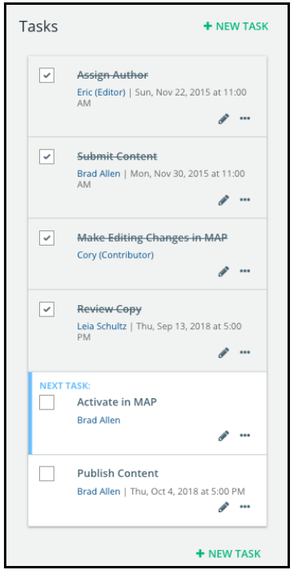
You’ll see workflows on content and initiatives in the Studio app. Workflows outline the tasks that need to be done, by whom and by when, to move content and campaigns from start the finish.

Workflows are designed to help manage the production of content and initiatives by providing key details like task name, who is going to complete the task, and the task deadline. You can set up templatized workflows that always appear on a certain content type, but you can manually update workflows whenever you need to.

When a task is marked as complete, Kapost will alert the next task owner in the workflow that their task is up next to complete, to keep production moving along.

Editing Tasks
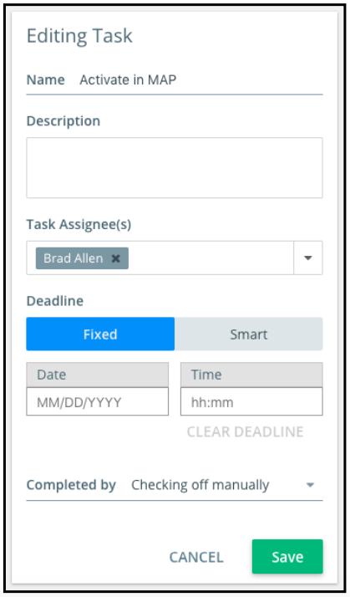
To edit a task, such as when you’d like to change its owner, deadline, or details, click on the pencil icon to expand the task details.

There are open text fields to edit the task name and its description. To edit the task assignee, select the correct person from the drop-down menu.

You can choose a fixed or smart deadline for the task. A fixed deadline is simply a manually entered date and time for the task due date. A smart deadline is dependent on a task either before or after in the workflow.

Use the Completed by drop-down menu to select what action will mark the task as complete in the workflow.

Click the green Save button when you are finished editing the task to record your updates.
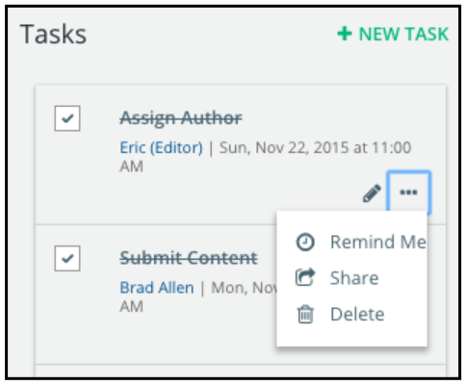
You’ll see a green + New Task button at the top and bottom of workflows when you need to add or remove a task. When you add a new task, drag and drop it to the right place in the workflow.

Click on the ellipsis to open a menu with options to delete a task, share a task with a team member, or schedule a reminder for a task.

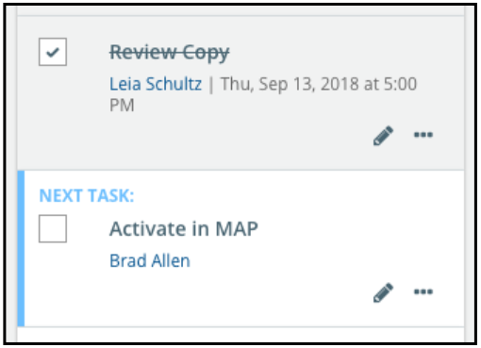
Checking Off Completed Tasks
Once you’ve completed a workflow task in Kapost, mark it as complete by checking the checkbox in the top left of the task. That will trigger Kapost to notify the next task assignee that their task is up next.

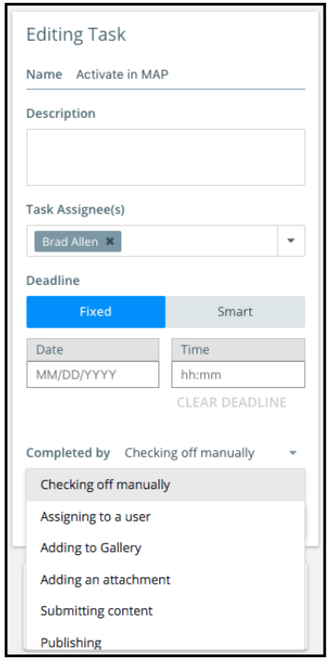

Some workflow tasks are only marked as complete when the task assignee completes a certain action. This action is specified in the Completed by drop-down menu.

Once the task assignee completes that action, such as adding the content to the Gallery, Kapost automatically marks the task as complete and notifies the next task assignee that their task is up next.

For more information on making workflows work in your content operation, watch this short video tutorial.

Workflow Best Practices:
- When you create a new piece of content in Kapost, the first thing you should do is make sure the workflow tasks all have assignees, deadlines, and any other important details to ensure a smooth creation process. Adding deadlines will populate your calendar in the Studio app with the tasks and their key details.
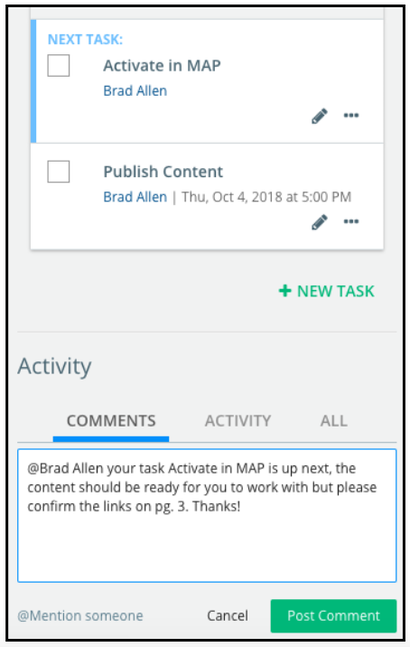
- Manually edit workflows as needed. Delete tasks that aren’t relevant for the content being created, or add a new task when one is needed.
- Don’t change the names or titles of tasks in the existing workflow tasks. This ensures accurate reporting and saved task views on the calendar and catalogs.
- You’ll see workflows on content and initiatives. Initiative-level workflows should be a higher level overview of work to be done to execute a whole campaign, while content-level workflows are specific to that piece of content.
- Use the activity feed below the workflow to @-mention team members and provide notes and helpful information for them to reference as they complete their task on the content.
- Contact your Kapost admin if you would like to add or delete a task to the templatized workflow in settings.

[Company Name]’s Custom Workflows
The workflow will prepopulate based on the settings your Admin configures for content and initiatives. If you believe an update to the standard workflow is needed, please notify your Kapost Admins.
[INSERT A DETAILED OUTLINE OF YOUR WORKFLOW STEPS THAT HAVE BEEN SET FOR YOUR KAPOST USERS. INCLUDE BOTH INITIATIVE AND CONTENT DETAILS. IF THERE ARE SPECIFIC TASKS YOU REPORT ON OR USE FOR CALENDARS, THAT SHOULD BE INDICATED]

Tagging Content
Let’s talk about tagging, or putting key custom fields, on content (and initiatives).

Tagging in Kapost is crucial for categorizing, finding, and reporting on the content and campaigns in your content operation. This is what fuels your taxonomy and powers your metadata so your executives can recognize progress and plan for the future.

Find the custom fields section on content below the body of content. The categories and tags in this section are set up by your Kapost Admin when your organization implements Kapost; they can be edited later as needed.
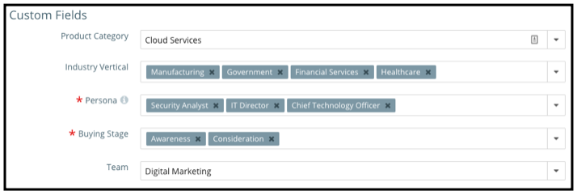
Red asterisks mark custom fields as mandatory to fill in—but to have the best system data, every field should be completed so that you can search and filter all the content in your content inventory.

If you aren’t sure which tags to apply, use the activity feed below the content workflow to @-mention your Admin or another team member who can advise.
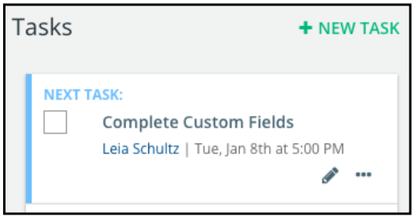
As a best practice, make the first task in every content workflow to complete the custom fields section. This ensures that tagging is never overlooked and your system data is pristine. (It’s what we do here at Kapost!)

Your content operation’s tag structure (your taxonomy) is a vital element of its success. Read this article for more information about tagging your content and initiatives.

[Company Name]’s Custom Fields
[LIST CUSTOM FIELDS THAT HAVE BEEN SET FOR YOUR KAPOST USERS AND HOW THEY SHOULD BE USED. THERE’S OFTEN CONFUSION AROUND THE VALUES, WHAT THEY MEAN AND WHAT THEY DON’T MEAN. ALSO INCLUDE ANY INFORMATION AROUND MANDATORY FIELDS, WHY THEY ARE MANDATORY, AND WHAT ACTIONS WILL BE PREVENTED BEFORE THESE FIELDS ARE FILLED OUT]

Activity Feeds
Use the activity feed on content and initiatives to @-mention team members or groups and see updates on the content or initiative’s progress.

Type the “@” symbol in the activity feed and the name of the person or the group name you’d like to communicate with (with no space in between the @ symbol and their name), and Kapost will show you a menu of the users in the platform based on the name.

Select the right person(s) to @-mention, type your comment in the open text field, and click the green Post Comment button to publish your comment. The person you @-mentioned will receive an email and a new notification in Kapost alerting them to the comment.

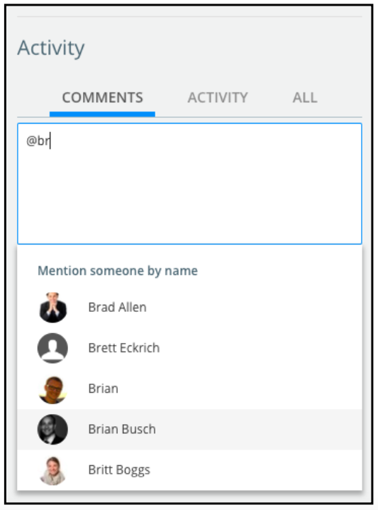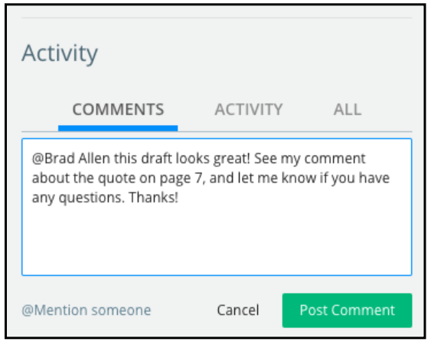

Each activity feed has three tabs: Comments, Activity, and All.

Click on the Comments tabs to see only the comments that people have left on that content. Click on the Activity tab to see only updates on the content’s production progress. Click on the All tab to see both comments and updates.
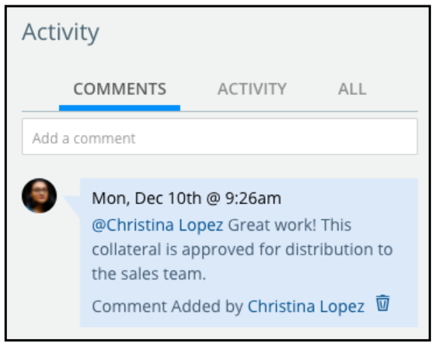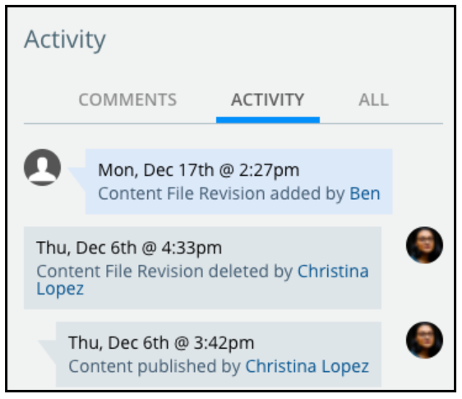

Activity Feed Best Practices
- Communication among your teammates is key as content is produced. Use the activity feed to @-mention the people you’re working with to provide relevant updates and details or to ask questions, all within Kapost so you don’t need to send emails back and forth.
- The activity feed records a timeline as content goes from planned to in progress to complete, as well as production updates like when task deadlines are shifted. Managers can review activity feeds to have visibility into progress and use them as a basis for planning moving forward.

For more training on using activity feeds, watch this short video tutorial.

Creating Initiatives
Initiatives are the campaigns or plans your team will execute in Kapost, like a product launch, nurture campaign, or an event. With an initiative, you’ll collect all the ideas, content, and other details that support the campaign you’re working on.
- Think of an initiative as a container for all the content related to a thematic or strategic campaign.
- An initiative can contain an unlimited number of content of any type. At a minimum, it should contain at least two pieces of related content or content that serves the same larger objective.

To create a new initiative, click on the green Create button in the top navigation bar. In the pop-up modal that appears, select the Initiative tile.

Give your new initiative a title, select its a type, and enter start and end dates. This information can be edited later as needed.
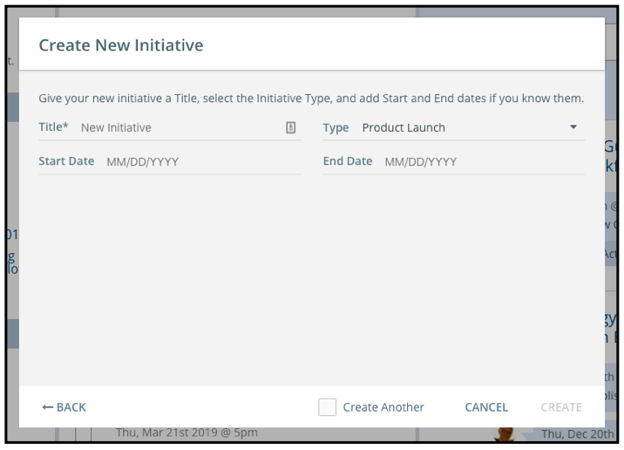

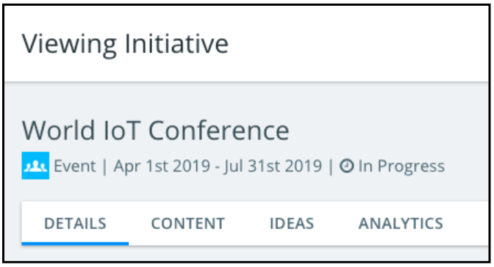

When you click Create, you’ll be taken to your new initiative. Each initiative view in Kapost has four tabs that you can toggle among depending on what information you need to see or what action you need to complete.

- Details: This tab is where you update important background information for your initiative, such as its start and end date, owner(s), and relevant custom fields. This information ensures finding and reporting on the initiative. You also interact with the initiative’s workflow from this tab.
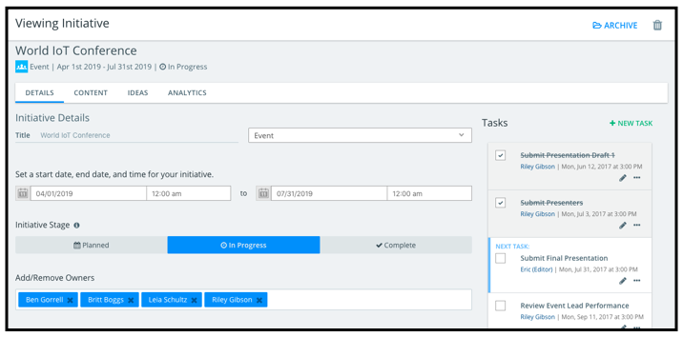
- Content: The Content tab shows a list of all the content in an initiative and provides at-a-glance details, like content stage and the next task up in the content workflow. Click through to the content from this list, and complete bulk actions on the content in this list.
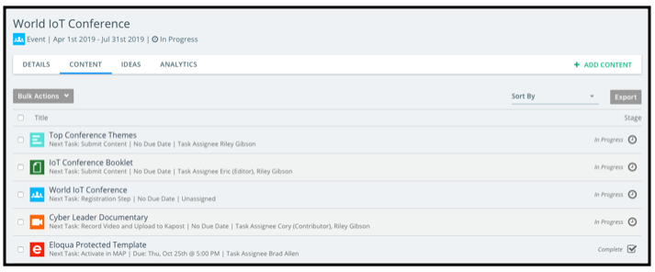
- Ideas: The Ideas tab displays the ideas that were submitted and approved or rejected for the initiative. You can also add new ideas for content for the initiative in this section. Some initiatives won’t have any ideas in this tab if none were involved in planning the initiative.
- Analytics: The Analytics tab displays data for completed initiatives in Kapost. The data here provides insights around the content in an initiative, such as social channel shares and content downloads.

You can add content to initiatives in a few different ways:
- Add new content individually. Hand-select the type(s) of content to add to your initiative.
- Add existing content individually. Select existing content in Kapost to add to your initiative.
- Add a template of content to populate your new initiative upon its creation with predetermined content needed to execute it based on the initiative type. This template can be manually updated.

[Company Name]’s Initiative Types
Just like when you create content in Kapost and you need to choose a content type, when you create an initiative in Kapost, you will need to choose an initiative type. Our initiative types are:
[INSERT YOUR INITIATIVE TYPES AND DEFINITIONS. ALSO INCLUDE ANY INITIATIVE NAMING CONVENTIONS THAT YOUR USERS SHOULD FOLLOW AS WELL AS ANY DETAILS ABOUT HOW YOU LEVERAGE INITIATIVES AT YOUR COMPANY]

[Company Name]’s Initiative Templates
Initiative templates automatically add predetermined content assets to an initiative when it’s created, making it easy to execute standard initiatives. These templates add multiple assets in one click.
[INSERT INITIATIVE TEMPLATES AND DEFINITIONS]

The Calendar
Your Kapost Calendar in Studio helps you and your team members stay on top of your editorial plans and production status. The calendar populates with workflow task deadlines.
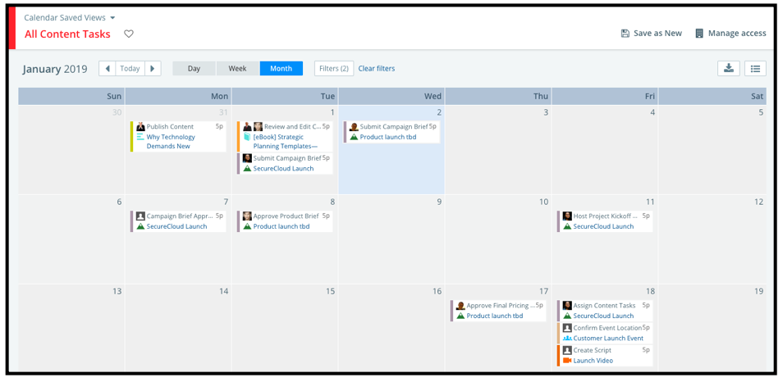
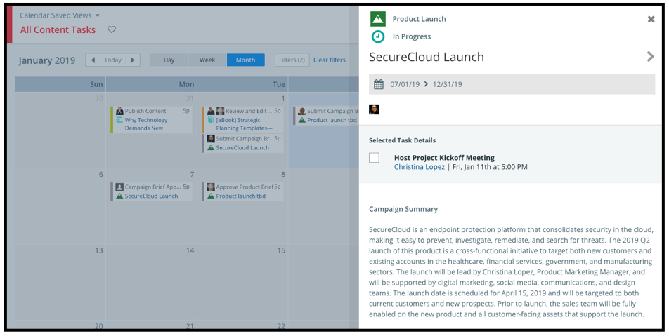
At a glance, your calendar will have tiles for task names on content and initiatives, when they’re due, and the task assignee.

Click on a tile to expand a preview pane with more information on the task. From the preview, you can click directly through to the content or initiative that task is on. You can also check off a task as complete from this preview pane.

Click on the legend icon to sort your calendar view by a certain content type.
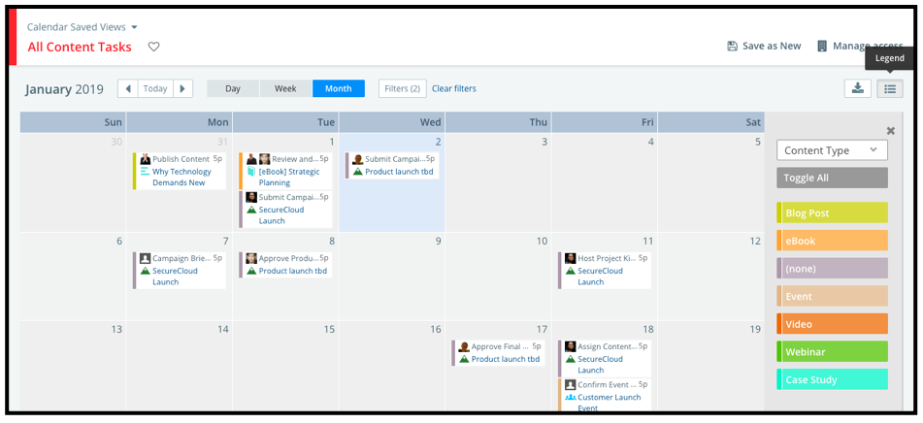

Use the legend and the filter options to set up saved views for your calendar to show just the content or initiatives that matter to you. Use Manage Access functionality to control the privacy of that view.

[Company Name]’s Calendar Saved Views

[LIST SAVED Calendar VIEWS THAT CUSTOMER HAS CREATED AND SHARED]

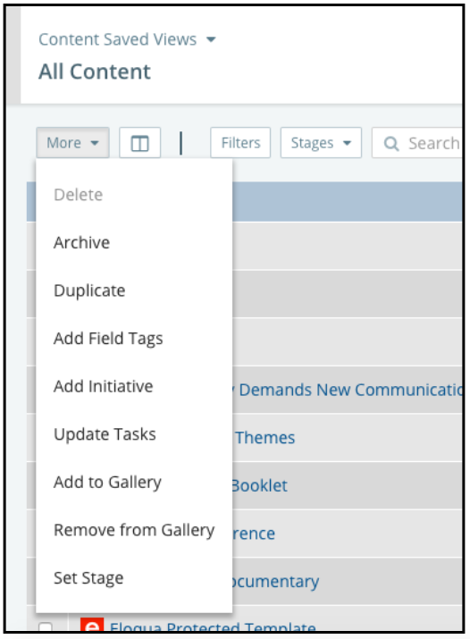
Bulk Actions
You’ll see a More drop-down menu in several places in the Studio app, including your catalogs and on content assets, which provide a list of bulk actions options.

Bulk actions enable you to select an action to apply to multiple ideas, content assets, or initiatives to speed up certain tasks, like adding tags to content.

In your catalogs, like the Content Catalog pictured to the right, select multiple pieces of content and click on the More drop-down menu to apply the same action to all the pieces of content with a click.

When you select certain bulk action options, Kapost will open a pop-up modal that will guide you through completing the action.

Publishing Content
Kapost allows you to update content URLs in order to retrieve analytics on content you published outside of Kapost, manually published, or content you published before using Kapost.
- Follow these instructions to manually update a URL.
- Read this article to understand why you would publish to the Kapost cloud. If publishing to the Kapost cloud is not an option, please contact your Kapost Admin to assign it as a publishing destination.

[Company Name]’s Kapost Integrations
While Kapost allows us to view emails and landing pages that are built in [INSERT MARKETING AUTOMATION TOOL NAME], we have a specific process that helps us manage working together with our marketing automation teams. [INSERT MARKETING AUTOMATION SPECIFIC PROCESS]
[INSERT OTHER INTEGRATION DESCRIPTIONS, PROCESSES, VALUE STATEMENTS, ETC.]

Additional Information
[INSERT ADDITIONAL INFORMATION YOUR KAPOST USERS SHOULD ABOUT HOW YOU USE THE STUDIO KNOW INCLUDING RESOURCE LINKS AND OFFICE HOURS INFO. IF YOU HAVE OTHER INTEGRATIONS OR TECH STACK INFORMATION FOR YOUR TEAM, THAT SHOULD BE ADDED AS WELL]

The Kapost Gallery [Delete if not needed]
The Kapost Gallery App is where you’ll keep your completed and approved content in Kapost. Your sales team and other stakeholders should use Gallery as a go-to resource when they’re looking for content.

Why We Use Gallery
[INSERT DETAILS ABOUT THE VALUE YOU GET OUT OF USING THE KAPOST GALLERY. TEACH YOUR TEAM WHY IT’S SO IMPORTANT TO USE THIS PART OF THE TOOL]

Who Accesses Our Galleries
[WHO ARE YOUR AUDIENCES? WHAT ARE YOUR COLLECTIONS FOR EACH OF THESE AUDIENCES?]

How to Organize Content for the Gallery
[HOW SHOULD CONTENT CREATORS USE THE GALLERY SECTION IN STUDIO WHEN THE ASSETS ARE COMPLETED?]

Who on Our Team Manages the Gallery
[INSERT GALLERY ADMIN CONTACT INFORMATION]

Kapost Glossary

Archiving Content and Initiatives: Archiving assets allows you to retire assets without deleting them. Archived content and initiatives are in read-only mode preventing any edits. Assets that are archived can be unarchived at any time to make edits. You will not see content assets or initiatives anywhere except in the Archived folder and custom reports. Kapost will keep running analytics on archived content. For more information on analytics for archived content, please read this article.

Assigned to Field: Assign any user of Kapost to this field in any content asset. They will be considered the Author of the content asset and these assets will appear on that user's dashboard. This field is a filter in the Content Catalog and Calendar areas of Kapost.

Calendar: Initiative, content, and event dates can be viewed and shared in a calendar format. Common uses are to create a publish calendar and share that calendar with important stakeholders.
Content Type: Documents, videos, collateral, and any other marketing assets you create.

Crowdsourcing: Crowdsourcing lets you gather ideas from external audiences (those without Kapost logins) via an online form. Crowdsourcing forms are accessed and shared using an external link. Ideas submitted via the form flow directly into your ideas tab inside Kapost and must be approved before they can move into content production. Common uses for for gathering requests from other teams or sourcing ideas from a wider audience than your content team.

Custom Fields: (Metadata tags) These tags/fields let you capture unique data about your content that is specific to our company’s needs. This data makes it easier to filter, find, and run reports on content and can also support your production process by capturing key data needed to complete production tasks. Examples include Product Line or Video Script Text.

Field Tags: This is an all encompassing term used to explain custom fields as well as non-custom fields in Kapost like Initiatives, Personas, and Buying Stages. This term displays in the bulk actions menu of the Content tab in Studio as well as the Content Details and Manage Content pages in Gallery.

Ideas: Ideas capture concepts for future content creation. All submitted ideas will need to be approved before turning into content.

Initiative: Multiple assets can be grouped together into an initiative. Initiatives typically represent a larger project, marketing initiative, campaign, or theme. For example you can group together all assets that support an event or product launch.
Initiative Templates: Initiative templates automatically add content asset shells to an initiative, making it easy to run standard initiatives over and over. These templates add multiple assets in one click,increasing efficiency for initiatives that you run frequently, such as a standard product launch.

Initiative Type: Create different types of initiatives to categorize your groupings of content. For example you might have product launches or web events to as initiative types.
Instance: Your company’s custom Kapost URL address.

Publish Button: Click this button in any content asset to utilize direct publishing to destinations integrated with Kapost, like a CMS, YouTube, SlideShare, etc. or to set the status of content to Published. This is an important step in finishing the production of any asset.
Submit Button: Click this button in any content asset put the asset into a submitted status.

Workflow: Workflows are defined for each content and initiative type. Workflows contain a set of tasks. You will be assigning task owners and deadlines to each task to provide visibility and accountability throughout the content asset’s production lifecycle. Workflow tasks will help inform on the status of assets in multiple places, including the editorial calendar.

Smart Deadlines: A smart deadline is a deadline that is set to be dependent on another task. The smart deadline will auto-populate a deadline based on the other task's deadline or completion date. It is possible to link a smart deadline to any other task in the workflow.

Smart Tasks: A smart task is a task that will automatically get checked off when a specific action is completed. Smart tasks help to automate the workflow.

Stages: Identify the status of your content as planned, in progress, or complete by changing the content status for individual assets. The stage will automatically change to In Progress when the first task is checked off, and you will be prompted to move the stage to Complete when the last task gets checked off. You can always override this automation.

Learn more at help.kapost.com

